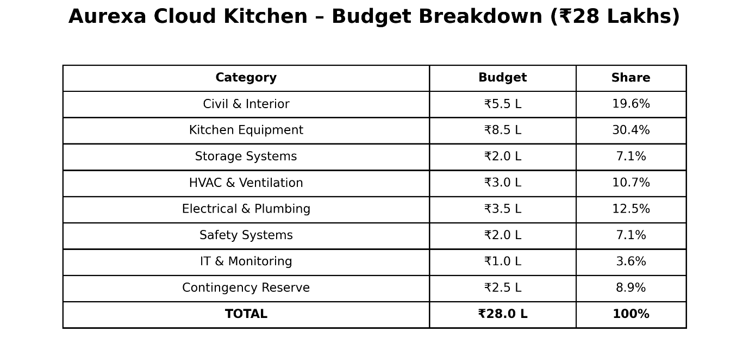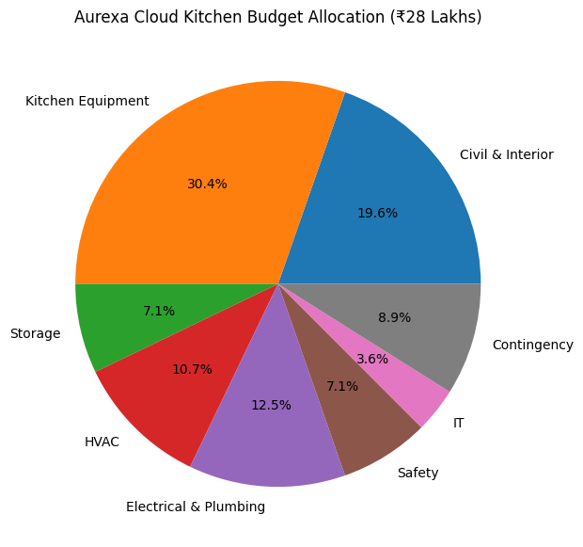

Slide 3 – Cost Optimization & Risk Analysis
Title:
Cost Optimization & Risk Management
Left Side: Cost Optimization
✅ Bulk Procurement of Materials
✅ Energy-Efficient Equipment
✅ Third-Party Delivery Integration
✅ In-House Bread Manufacturing
✅ Modular Kitchen Layout
Right Side: Risk Management
⚠ Material Cost Increase → Early Procurement
⚠ Equipment Delivery Delay → Multiple Vendors
⚠ Budget Overrun → ₹2.5 Lakh Contingency Fund
⚠ Regulatory Delays → Early Documentation
Bottom Line
Expected Operational Cost Reduction: 10–15% annually
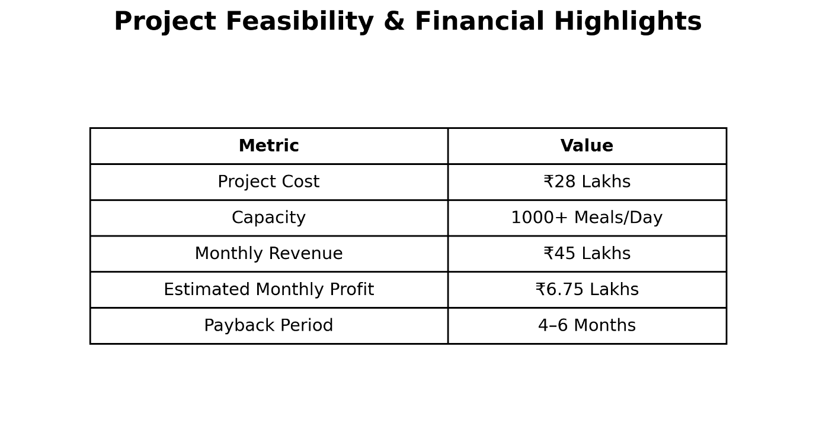
Recommendation
✔ Within Client Budget
✔ Supports 24×7 Operations
✔ Meets Safety & Hygiene Requirements
✔ Strong Return on Investment
✔ Completion Target: 3 Months
Final Statement
"Aurexa recommends proceeding with the proposed financial plan as it ensures operational efficiency, safety, hygiene, and long-term financial sustainability."

Yukta — YUK-tuh
Sanskrit-inspired; associated with being connected, joined, or well-equipped.
Tagline: Smartly Connected.

Anvexa
Inspired by Anvaya (connection) + a modern tech-style ending
Tagline: Connected by Intelligence.
A premium name for a company integrating AI, cloud platforms, and business systems.
Yukti Labs
Yukti means ingenuity or a skilful method
Tagline: Smart Solutions. Real Results.
Indian in meaning, modern in presentation, and especially suited to a problem-solving technology business.

Mandatory points to cover
- Revenue model — How the company earns money.
- Current financial position — Revenue, expenses, profit, and cash flow.
- Funding requirement — How much investment you need and why.
- Utilization of funds — Where every rupee of investment will be spent.
- Financial projections — Expected revenue, expenses, and profits for the next 3 years.
- Profitability and break-even — When the company expects to cover its costs.
- Investor benefits — Equity, potential returns, dividends, and growth opportunities.
- Risk management — How you will handle losses, delayed payments, and unexpected expenses.
- Financial transparency — Regular reports, budgeting, and accountability.
- Unique points to stand out from the other 3 teams
- These are the points I'd prioritize to make your finance pitch more impressive.
- 1. Investor Money Protection Plan
- Set aside a defined contingency reserve and release funds in stages against measurable milestones. This demonstrates financial discipline.
- 2. Three-Scenario Financial Forecast
- Present optimistic, realistic, and worst-case projections. Show investors that you have a plan even if business growth is slower than expected.
- 3. Cash Runway Guarantee?
- Calculate how many months the company can survive using its available cash. Commit to monitoring runway and taking corrective action if it falls below a defined threshold—without promising a guaranteed outcome.
- 4. Milestone-Based Investment
- Allocate funding in phases based on targets such as product launch, client acquisition, and recurring revenue growth instead of spending the entire amount without checkpoints.
- 5. Financial Transparency Dashboard
- Offer investors a periodic dashboard showing revenue, expenses, cash balance, project margins, and progress against targets.
- 6. Client Profitability Analysis
- Show that you measure which projects and clients generate the highest margins, so growth focuses on profitable business rather than revenue alone.
Nishant – Chief Financial Officer (CFO) Revenue model Financial projections Funding requirements
Janhvi – Director of Investor Relations
- Investor benefits
- Investment proposal
- ROI and growth story

